In this project I have compared the performance and visual output of two images. The two images are “jpeg.jpg” and “sailboat.jpg”. The two main algorithms used in comparison is Averaging and Lightness. I also tested Luminous with different w1, w2,w3 values. I found that for sailboat which was a larger image, Luminous was ran more quickly than the other algorithms. Averaging was very close to the run time of Luminous. On the other hand, the jpeg.jpg image which is much smaller than the sailboat, had a better run time with the averaging algorithm.

Sailboat averaging:

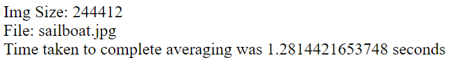

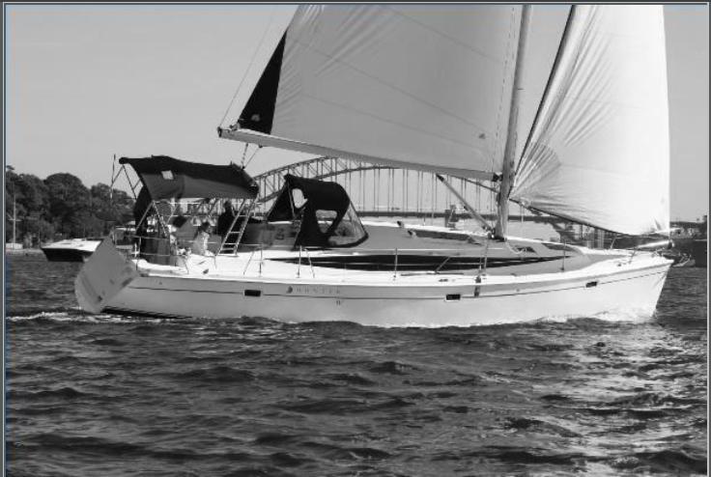

Sailboat lightness:

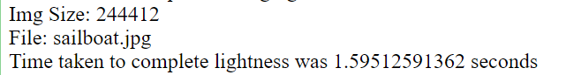

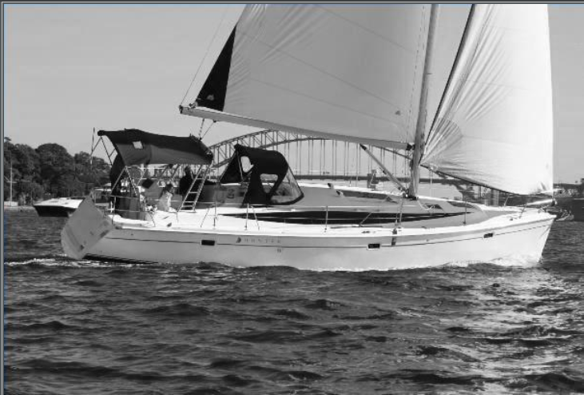

Jpeg averaging:

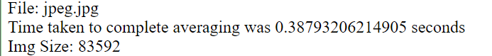

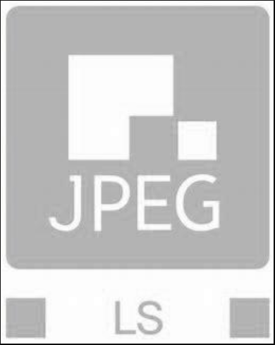

Jpeg Lightness:

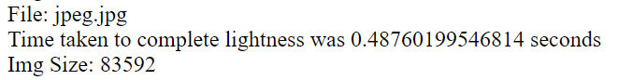

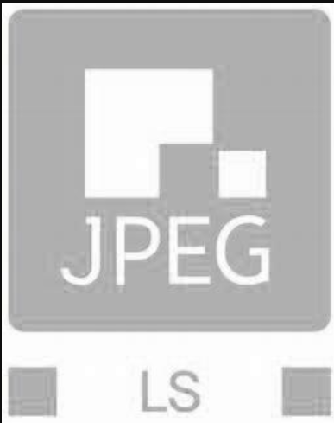

Sailboat luminous W1 = 1, w2 = 1, w3 = 1

W1

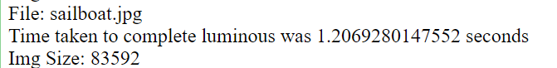

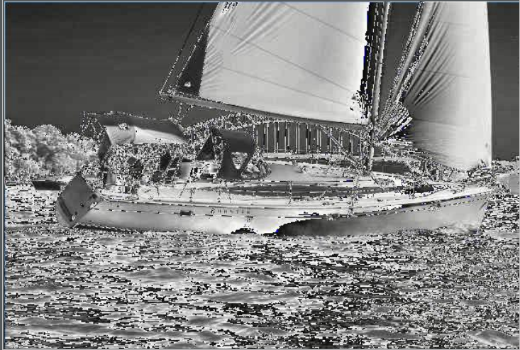

Sailboat Luminous w1 =.3, w2=.6, w3=.1

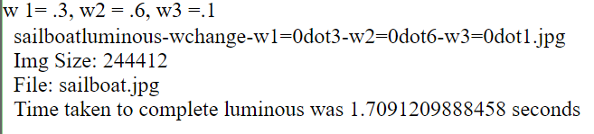

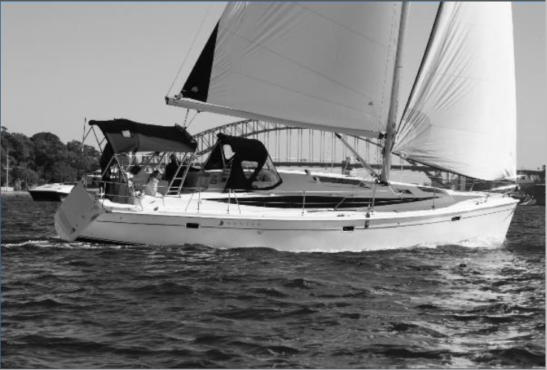

Sailboat Luminous w1 = .2,w2 =.2, w3 =.2:

